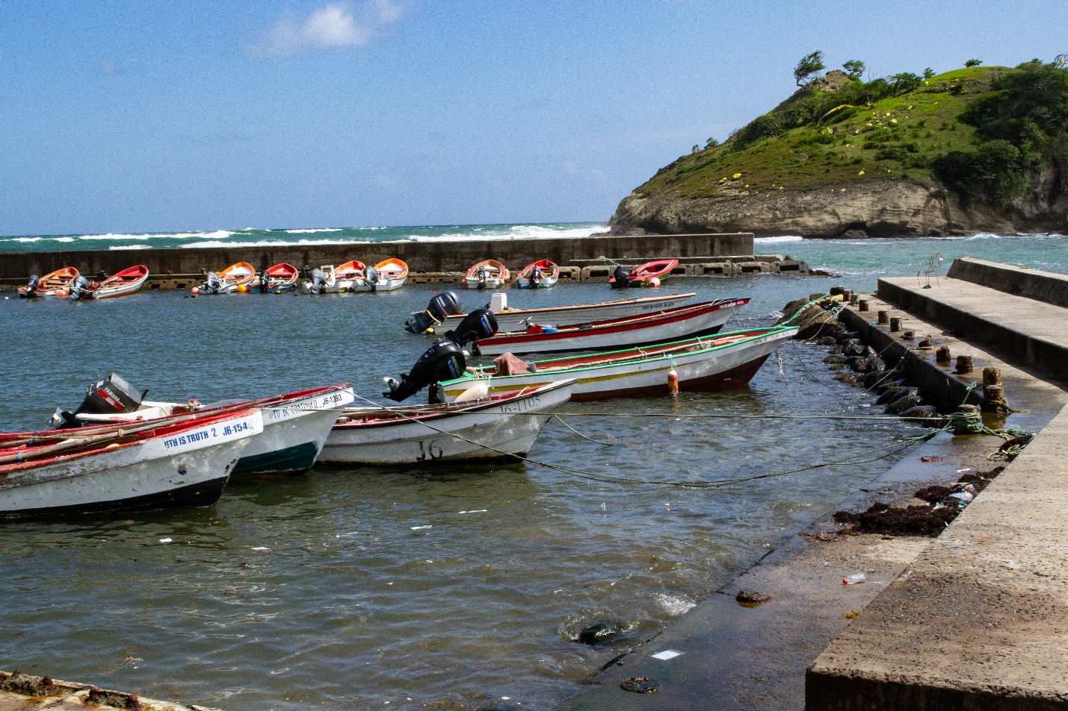
© Antonio Deterville

Methodological Guidebook for Coast Station & MRCC Emergency Telecommunications Survey

Caribbean Spectrum Management Taskforce

25 October 2021

Table of Contents
Part A: Introduction 3
Background 3
Motivation 3
Objectives 4
Scope 4
Intended Data Use 5
Part B: Survey Design 6
Section 1: General Station Information 6
Section 2: Station Personnel 7
Section 3: Radio Equipment 8
Section 4: Station Operations 9
Section 5: Policy & Regulatory Provisions 10
Part C: Planned Outputs & Templates 12
Registry of Coast Stations and MRCCs within the Caribbean 14
Registry of Channel Usage within the Caribbean’s Marine Band 15
Appendix: Draft Survey 16

Part A: Introduction

Background
Seafarers are exposed to a wide range of risks at sea, from piracy to natural disasters. As a primary means of emergency communications, the International Convention for the Safety of Life at Sea, SOLAS (IMO 2004), and the 2012 Cape Town Agreement (IMO 2012), obliges all passenger and cargo ships, as well as fishing vessels exceeding 300 gross tonnage (GT) (over 24 metres in length) to be outfitted with two-way VHF radiotelephone apparatus and licensed operators.
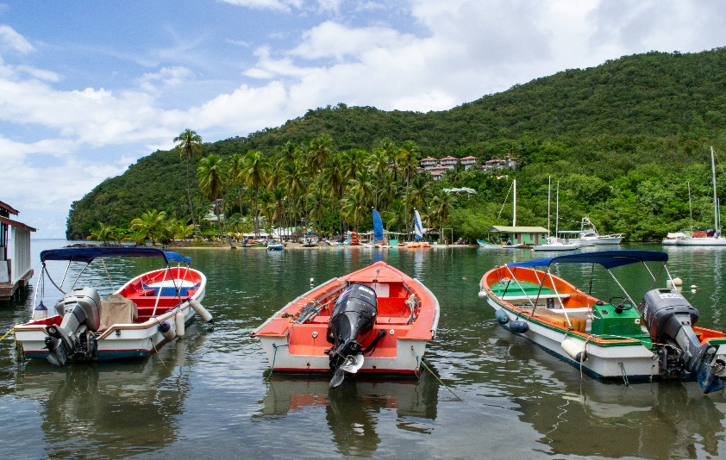
Small-scale fishing vessels, usually 12 metres and below, are recommended but not obligated to carry radio equipment by international law. These vessels account for roughly 93.1% of the Caribbean commercial capture fisheries fleet (CRFM 2018). Small-scale fishing vessels are subject to particularly high levels of exposure at sea, and all too often face crisis situations with no communications recourse. Investigations of the Caribbean ICT Research Programme have found a variety of shortcomings that perpetuate low levels of radio adoption among small-scale fishers. These include but are not limited to low levels of compliance with international obligations1,2 as well as inadequacies in various operational matters such as radio licensing procedures and application forms; marine working channel information; public awareness on the rationale for radio licensing; and radio training for seafarers.
©Antonio Deterville
Figure 1 Three Small-scale Fishing Vessels at the Tourist Hotspot of Marigot Bay, St. Lucia

Motivation
Maritime Rescue Co-ordination Centres (“MRCCs”) and coast stations are often the first to respond to distress, urgency and safety alerts by seafarers; playing a critical role in relaying emergency communications and directing vessels to assist those in need. As for all coast stations and marine band radio operators, they are obligated to maintain watch over the international emergency channels: VHF channels 16 and 70, as well as 2182kHz.
Publicly available data on coast station and MRCC infrastructure and operational capacities are currently unavailable. This limits governments, regulators, as well as national and regional agencies with mandates and interests in maritime operations, from gauging the effectiveness and efficiency of provisions, the adequacy of available resources, and assessing existing gaps. The Caribbean Spectrum Management Taskforce (“SMTF”) has undertaken to perform baseline data gathering on emergency communications in the maritime bands as a first step to evaluating gaps.

Objectives
The SMTF MRCC and Coast Station Survey (see Appendix for draft survey instrument) sets out to perform baseline data gathering on emergency maritime communications, to identify the state of emergency telecommunications in the Caribbean, the gaps which exist, and gap-filling measures.
Additionally, a resource pack for seafarers, particularly small-scale fishers, will be produced as outputs of this exercise, as captured in the Planned Outputs & Templates section of this guide.

Scope
The SMTF MRCC and Coast Station Survey sets out to survey managerial and technical staff from national coast stations and MRCCs within CTU member states. It gathers the following types of information:
- General station information: what coast stations and MRCCs exist within the Caribbean? Who operates them? How and through what channels can seafarers contact them?
- Station personnel: what job positions are in place for
- Radio equipment: what radio equipment are available to these stations
- Station Operations: what are the scheduled transmissions made by these stations, and what channels are used for these transmissions?
- National maritime communications policy and regulatory provisions: what policy and regulatory provisions exist for the marine channel assignments, band plans and channel availability, licensing fees, and subsidies on operating these stations?

Intended Data Use
The findings of this survey will articulate with those of ITU/CTU/TATT Smart Seas Toolkit (SST) for Disaster Resilience to, among other things, develop:
- A registry of coast stations and MRCCs within the Caribbean
- A simulated coverage map of coast stations and MRCCs within the Caribbean
- A registry of channel usage within the marine band, including primary working channels for all coast stations (other than VHF channel 16)
- Print-ready, wallet-sized call card design with MRCC and coast station contact details by country, for printing and distribution by fisherfolk organizations, ports, etc.
- An output report, which includes the above artefacts, along with a simulated coverage analysis and recommendations to fill any uncovered gaps based on the responses
- A policy brief, with recommendations to improve the state of emergency communications provisions offered by existing coast stations and MRCCs within the Caribbean
The results of this survey therefore contribute to the larger picture, of:
- Determining the state of emergency telecommunications within the Caribbean
- Identifying the gaps and recommending gap-filling solutions
- Informing future policy and regulatory decisions
- Harmonizing the Caribbean community through a common priority: safety at sea

Part B: Survey Design
The survey (see Appendix) is designed to gather the most important data under the SMTF’s initiative to “conduct a survey of marine communications to include infrastructure and national Maritime Rescue Coordination Centre (MRCC) arrangements, as well as relevant national policy and regulatory provisions, channel use, operations and associated capacity”. It comprises 5 sections:
- Section 1: general station information
- Section 2: station personnel
- Section 3: radio equipment
- Section 4: station operations
- Section 5: policy and regulatory provisions

Section 1: General Station Information
This section captures the names, positions and contact details for MRCCs and coast stations within the Caribbean. Table 1 summarizes the fields and respective intended use of data gathered.

Table 1 MRCC & Coast Station Survey Section 1 Design
ID | Field | Type |  | Data Use
 |  | Short Answer | Check-box
S1-01 | Station name |  |  | to populate a registry of, and map the coast stations and MRCCs in the Caribbean
S1-02 | Callsign
S1-03 | Station type
S1-04 | Country
S1-05 | Areas of responsibility
S1-06 | Agency responsible |  |  | to identify sources of inadequacy and best practice
S1-07 | Physical address |  |  | to populate a registry of, and map the coast stations and MRCCs in the Caribbean
S1-08 | Position |  |  | to populate a registry of coast station and MRCC contacts for the Caribbean, and in coverage simulations
S1-09 | Site elevation above sea level |  |  | to simulate signal coverage
S1-10 | Station contact details |  |  | to populate a registry of coast station and MRCC contacts for the Caribbean and for follow up if necessary

Section 2: Station Personnel
This section sets out to capture the station personnel required for coast stations and MRCCs in the Caribbean, as well as the responsibilities and workloads. Additional entries to the Station Personnel section can be completed using the additional sheets in the survey’s Appendix A. Table 2 summarizes the fields and respective intended use of data gathered.

Table 2 MRCC & Coast Station Survey Section 2 Design
ID | Field | Type |  | Data Use
 |  | Short Answer | Check-box
S2-01 | Job title |  |  | to identify the key personnel responsible for, and involved in, the daily operations of coast stations and MRCCs
S2-02 | How many in this role per shift? |  |  | to assess whether provisions are adequate and to potentially identify best practice
S2-03 | Prerequisite knowledge, skills, experience and certifications |  |  | to assess whether the job-holder’s knowledge, skills, experience and certifications are suitable for coast stations & MRCCs in the Caribbean
S2-04 | Average weekly working hours |  |  | to assess whether workloads are reasonable for efficient operations and to potentially identify best practice
S2-05 | Shift duration
S2-06 | Responsibilities |  |  | to identify the scope of work and the tasks and responsibilities vested with each staff member

Section 3: Radio Equipment
This section sets out to capture the technical specifications of the coast station/MRCC radio transceiver system, and their connected antennas. Additional copies of the Radio Equipment section can be completed using the additional sheets in the survey’s Appendix B. Table 3 summarizes the fields and respective intended use of data gathered.

Table 3 MRCC & Coast Station Survey Section 3 Design
ID | Field | Type |  | Data Use
 |  | Short Answer | Check-box
Transceiver specifications
S3-01 | Transceiver position6 |  |  | to simulate signal coverage, which may be different from the station’s location
S3-02 | Manufacturer |  |  | to consult the equipment’s technical specifications for verifying the data gathered, obtaining all other data for simulations, and to compare equipment among the stations surveyed
S3-03 | Model number
S3-04 | Installation date |  |  | to determine the age of the equipment and whether it requires maintenance/upgrades
S3-05 | Last inspection |  |  | to confirm whether inspection compliance is met. May provide rationale on station performance
S3-06 | Frequency band/s |  |  | to identify and map the marine band usage, and identify common channels used among stations
S3-07 | Generator available? |  |  | to determine and estimate station uptime during outages
S3-08 | Generator discharge time |  |  | to determine the additional service availability during outages, in gauging the system’s capabilities during national emergencies
Antenna specifications
S3-09 | Manufacturer |  |  | to consult the equipment’s technical specifications for verifying the data gathered, obtaining all other data for simulations, and to compare equipment among the stations surveyed
S3-10 | Model number
S3-11 | Azimuth |  |  | to be used in station identify the direction of signal propagation, in the case of directional antennas

Section 4: Station Operations
This section sets out to capture the channel usage, schedules and information transmitted by stations within the Caribbean. Table 4 summarizes the fields and respective intended use of data gathered.

Table 4 MRCC & Coast Station Survey Section 4 Design
ID | Field | Type |  | Data Use
 |  | Short Answer | Check-box
Channel bands, uses & schedules
S4-01 | Channel/frequency |  |  | to identify and map the working channels, as well as populate a registry of and map the channel use and transmission schedule for coast stations and MRCCs in the Caribbean
S4-02 | Start time
S4-03 | Channel use
Information sources
S4-04 | Information type |  |  | to identify the classifications of data available to coast stations and MRCCs
S4-05 | Information source |  |  | to validate the authenticity of the data received
S4-06 | Update period |  |  | to determine whether the routine update period is appropriate for the information conveyed
Data Capture and Record Keeping
S4-07 | Does your station record all incoming radio traffic? |  |  | to identify whether the station complies with SOLAS’ regulations for data recording
S4-08 | What format is the recorded data stored as? |  |  | to identify existing, and recommend best practices for, data storage formats in the Caribbean
S4-09 | Is the recorded data shared with other maritime safety agencies? |  |  | to identify data sharing practices in the Caribbean, and identify which agencies (national coast guards, regional MRCCs, etc.) are privy to this data
S4-10 | If yes, who is the data shared with?
S4-11 | Are backups made to the data recorded? |  |  | To identify and share best practices for data backup and sharing
S4-12 | If yes, what backup method is used?
S4-13 | If no, are there any future plans for backing up the data?
S4-15 | What data protection and privacy policies, if any, exist for the data that is being recorded?

Section 5: Policy & Regulatory Provisions
This section sets out to identify the policy and regulatory provisions which facilitate coast station and MRCC operation within the Caribbean. Table 5 summarizes the fields and respective intended use of data gathered.

Table 5 MRCC & Coast Station Survey Section 5 Design
ID | Field | Type |  | Data Use
 |  | Short Answer | Check-box
Q5-01 | Local telecoms regulator |  |  | to map the regulators with jurisdiction in the Caribbean
Q5-02 | What national tax concessions are available to aid in operational costs of stations? |  |  | to identify whether tax breaks and/or incentives are available to support the operations of national coast stations and MRCCs
Q5-03 | Which marine band plan does your country use? |  |  | to identify which common marine band channels are in use within the Caribbean
Q5-04 | What national policies exist for marine band radio licensing & radio use? |  |  | to identify what policies and regulations exist to guide the use and licensing of marine band radio communications within the sampled countries
Q5-05 | Yearly marine band license cost |  |  | to compare the operational costs associated in complying with licensing requirements across respondent countries.
Q5-06 | What national policies/ regulations exist for maritime search and rescue operations? |  |  | to identify the national policies, regulations or procedures to be followed during maritime search and rescue operations. Useful in assessing the validity of these regulations vis-à-vis the countries participating in this survey.
Q5-07 | Over what period do national regulators specify transceivers should be inspected? (years) |  |  | to determine how often RF equipment at coast stations should be re-inspected, for each of the surveyed country, and determine whether such a standard exists and is enforced.
Q5-08 | What is the maximum transmit power, specified by your country’s regulator? (dBm) |  |  | to identify the regulatory transmit power limits, and determine, through simulations, whether such a limit will allow coast stations and MRCCs to cover their areas of responsibilities.
Q5-09 | What national policies and provisions are in place to facilitate joint operations between neighbouring countries during maritime emergencies? |  |  | to identify the policies, regulations and procedures for cooperation between neighbouring states within the Caribbean during maritime emergencies, and identify barriers to cross-country collaboration.

Part C: Planned Outputs & Templates
This section details the expected outputs of this survey, and provides sample templates for population using the data gathered. It guides the survey development to only pose questions for which are essential for producing the outputs.
The planned outputs of this survey, originally identified in the “Intended Data Use” section, include but are not limited to:
- A registry of coast stations and MRCCs within the Caribbean
- A simulated coverage map of coast stations and MRCCs within the Caribbean
- A registry of channel usage within the marine band, including primary working channels for all coast stations (other than VHF channel 16)
- Print-ready, wallet-sized call card design with MRCC and coast station contact details by country, for printing and distribution by fisherfolk organizations, ports, etc.
- An output report, which includes the above artefacts, along with a coverage analysis and recommendations to fill any uncovered gaps based on the responses
- A policy brief, with recommendations to improve the state of emergency communications provisions offered by existing coast stations and MRCCs within the Caribbean
Each output can be mapped to their respective questions in the survey, as shown in Table 1:
Table 6 Mapping of Survey Inputs to Project Outputs
Output Document | Inputs from Survey (ID)
A registry of coast stations and MRCCs within the Caribbean | S1-01, S1-02, S1-03, S1-04, S1-05 & S1-10
A simulated coverage map of coast stations and MRCCs within the Caribbean | S1-01, S1-03, S1-08, S1-09, S3-01, S3-02, S3-03, S3-06, S3-09, S3-10 & S3-11
A registry of channel usage within the marine band, including primary working channels for all coast stations (other than VHF channel 16) | S1-01, S1-02, S1-03, S1-04, S4-01, S4-02, S4-03, S4-04, S4-05 & S4-06
A policy brief, with recommendations to improve the state of emergency communications provisions offered by existing coast stations and MRCCs within the Caribbean | Likely to draw on all outputs
Print-ready, wallet-sized call card design with MRCC and coast station contact details by country, for printing and distribution by fisherfolk organizations, ports, etc. | S1-01, S1-02, S1-03, S1-04, S1-05 & S1-09
An output report, which includes the above artefacts, along with a coverage analysis and recommendations to fill any uncovered gaps based on the responses | Likely to draw on all outputs

Sample registries for the coast stations and MRCCs in the Caribbean, as well as their channel use, are presented, as follows.

Registry of Coast Stations and MRCCs within the Caribbean
A registry of coast stations and MRCCs within the Caribbean can be developed, as shown in Table 7, using the responses taken from questions S1-01, S1-02, S1-03, S1-04, S1-05 and S1-10.

Table 7 Registry of Coast Stations & MRCCs within the Caribbean Template
Station Name | CS/ MRCC | Country | Countries of Responsibility | Position |  | Station Contact Details
 |  |  |  | LAT | LONG | Phone No. | Callsign | MMSI

Registry of Channel Usage within the Caribbean’s Marine Band
A registry of channel usage within the marine band can be developed, as shown in Table 8, using the responses taken from questions S1-01, S1-02, S1-03, S1-04, S4-01, S4-02, S4-03, S4-04, S4-05 and S4-06.

Table 8 Registry of Channel Usage within the Caribbean's Marine Band
Country | Station Name | Band | Channel/Frequency | Start Time | Channel Use

Appendix: Draft Survey
MARITIME RESCUE COORDINATION CENTRE
(MRCC) & COAST STATION SURVEY

SECTION 0: PRE-SURVEY INFORMATION & CONSENT FORM

OVERVIEW: | The Spectrum Management Task Force (“SMTF”) provides key input into the development of regionally harmonized policies for the planning and management of the radio-communication spectrum. As a technical group convened by the Caribbean Telecommunications Union, SMTF’s work contributes to ICT-enabled cooperation and development in the Caribbean. This survey on national coast stations and maritime rescue coordination centres (MRCCs) sets out to gather key data to ultimately strengthen communications resilience in the marine environment for improved safety at sea.  The survey findings will be used to identify gaps within existing policy, regulatory and capacity provisions and to formulate gap-filling measures.  - Gather the data required to populate a registry of, and map, the coast stations and MRCCs, as emergency contacts for all seafarers in the Caribbean region  - Gather the data required to simulate and estimate radio coverage by the coast stations and MRCCs within the region  - Identify the resources (human, infrastructure, policy and regulatory) required to operate and maintain coast stations and MRCCs within the region  - Identify, after analysis of the survey’s results, the baseline resources required to operate and maintain coast stations and MRCCs within the region  - Identifying key areas for research, and inform future decisions and spectral planning by regulators and policy makers
SCOPE: | This survey therefore sets out to gather the following data from national coast stations and MRCCs within CTU member states:  - General coast station/MRCC information  - Station personnel  - RF equipment  - Operations  - National maritime communications policy and regulatory provisions
PARTICIPANTS: | National coast stations and MRCCs within the Caribbean. Station managers may be able to complete the form, but may require support from technical staff to complete Sections 3 - 5.
COUNTRIES SURVEYED: | CTU member states
INSTRUCTIONS: | Please:  - enter all responses in English (in BLOCK LETTERS if handwritten)  - provide all positions in degrees, minutes, decimal-minutes notation  - complete additional roles and/or equipment templates in Appendices A and B  - email Nigel.Cassimire@ctu.int for additional questions and concerns
CONSENT FORM: | Participation:  Participation in this study is voluntary, and may be refused or terminated at any point, by the respondents. Any further questions, concerns and recommendations can be posed to Mr. Nigel Cassimire of the CTU, at: nigel.cassimire@ctu.int.  Benefits:  This survey will benefit all respondents, seafarers, regulators and policy makers, by producing a cadre of resources, which include but are not limited to:  - A registry of coast stations and MRCCs within the Caribbean  - A simulated coverage map of coast stations and MRCCs within the Caribbean  - A registry of channel usage within the marine band, including primary working channels for all coast stations (other than VHF channel 16)  - An inspection checklist, for coast station and MRCC equipment  - A policy brief, with recommendations to improve the state of emergency communications provisions offered by existing coast stations and MRCCs within the Caribbean  - Print-ready, wallet-sized call card design with MRCC and coast station contact details by country, for printing and distribution by fisherfolk organizations, ports, etc.  - An output report, which includes the above artefacts, along with a coverage analysis and recommendations to fill any uncovered gaps based on the responses  Risks:  This survey poses minimal risks to the parties involved, as the data collected should not pose any threats to the participants’ operations.  Confidentiality:  The data gathered from this survey will be used by the International Telecommunication Union (ITU), the CTU and member states, as well as academia in ongoing and future research. Processed data shall be made available to all CTU member states, through the resources produced at the end of this study. Identifying data, such as the country, station name and location, among others, will be published in the final report, in mapping the coverage of each station, and as part of a maritime safety contacts listing, published to all seafarers and stakeholders of maritime operations.  Agreement:  By signing this form, you agree to participate in this survey, permit the raw data to be shared within the research team, as well as published in future reports and studies. All outputs of this initiative, which capture the results and analysis of the data collected, will be made available to all participants for review prior to publishing. Therefore, agreeing to participate also covers consenting to receiving communications from the research team.
NAME OF PARTICIPANT |  | SIGNATURE | DATE

SECTION 1: GENERAL STATION INFORMATION

STATION NAME:
CALLSIGN:
STATION TYPE: |  | ☐ COAST STATION |  | ☐ MARITIME RESCUE COORDINATION CENTRE
COUNTRY:
AREAS OF RESPONSIBILITY:
AGENCY RESPONSIBLE:
PHYSICAL ADDRESS: | ADDRESS LINE 1
 | ADDRESS LINE 2
 | CITY
POSITION: | LATITUDE |  |  |  | LONGITUDE
SITE ELEVATION ABOVE SEA-LEVEL (m):
STATION  CONTACT  DETAILS: | TELEPHONE NUMBER 1 |  |  |  | TELEPHONE NUMBER 2
 | EMAIL ADDRESS |  |  |  |  | MMSI/MID

SECTION 2: STATION PERSONNEL

ROLE # 1
JOB TITLE:
HOW MANY IN THIS ROLE PER SHIFT?
PREREQUISITE KNOWLEDGE, SKILLS, EXPERIENCE & CERTIFICATIONS
WEEKLY WORKING HOURS: |  |  |  | SHIFT DURATION: |  | HOURS
RESPONSIBILITIES:
(LIST AS REQUIRED)

ROLE # 2
JOB TITLE:
HOW MANY IN THIS ROLE PER SHIFT?
PREREQUISITE KNOWLEDGE, SKILLS, EXPERIENCE & CERTIFICATIONS
WEEKLY WORKING HOURS: |  |  |  | SHIFT DURATION: |  | HOURS
RESPONSIBILITIES:
(LIST AS REQUIRED)

ROLE # 3
JOB TITLE:
HOW MANY IN THIS ROLE PER SHIFT?
PREREQUISITE KNOWLEDGE, SKILLS, EXPERIENCE & CERTIFICATIONS
WEEKLY WORKING HOURS: |  |  |  | SHIFT DURATION: |  | HOURS
RESPONSIBILITIES:
(LIST AS REQUIRED)

SECTION 3: RADIO EQUIPMENT

EQUIPMENT SET 1:
TRANSCEIVER SPECIFICATIONS
TRANSCEIVER POSITION: | LATITUDE |  |  |  |  |  |  | LONGITUDE
MANUFACTURER: |  |  |  |  |  | MODEL NUMBER:
INSTALLATION DATE: | DD | MM |  |  | YYYY | LAST INSPECTION: |  |  | DD | MM | YYYY
FREQUENCY BAND/S: | ☐ HF |  | ☐ VHF |  |  | ☐ UHF |  | ☐ OTHER: ____________________
GENERATOR AVAILABLE? | ☐ YES |  |  | ☐ NO |  | GENERATOR DISCHARGE TIME: |  |  | HOURS
ANTENNA SPECIFICATIONS
MANUFACTURER: |  |  |  |  |  |  | MODEL NUMBER:
ANTENNA AZIMUTH: | IN DEGREES

EQUIPMENT SET 2:
TRANSCEIVER SPECIFICATIONS
TRANSCEIVER POSITION: | LATITUDE |  |  |  |  |  |  | LONGITUDE
MANUFACTURER: |  |  |  |  |  | MODEL NUMBER:
INSTALLATION DATE: | DD | MM |  |  | YYYY | LAST INSPECTION: |  |  | DD | MM | YYYY
FREQUENCY BAND/S: | ☐ HF |  | ☐ VHF |  |  | ☐ UHF |  | ☐ OTHER: ____________________
GENERATOR AVAILABLE? | ☐ YES |  |  | ☐ NO |  | GENERATOR DISCHARGE TIME: |  |  | HOURS
ANTENNA SPECIFICATIONS
MANUFACTURER: |  |  |  |  |  |  | MODEL NUMBER:
ANTENNA AZIMUTH: | IN DEGREES

SECTION 4: STATION OPERATIONS

CHANNEL BANDS, USE & SCHEDULES
CHANNEL/FREQUENCY | START TIME (UTC) | CHANNEL USE
For example:
CH12 | 0900 | FOR DELIVERING DAILY MARITIME SAFETY WARNINGS AND WEATHER FORECASTS

INFORMATION SOURCES
INFORMATION TYPE | INFORMATION SOURCE | UPDATE PERIOD
For example:
METEOROLOGICAL DATA AND SEA STATE | TRINIDAD & TOBAGO METEOROLOGICAL SERVICE | DAILY, WITH ADDITIONAL BULLETINS ISSUED AS THEY ARISE

DATA CAPTURE AND RECORD KEEPING
DOES YOUR STATION RECORD ALL INCOMING RADIO TRAFFIC? | ☐ YES | ☐ NO
WHAT FORMAT IS THE RECORDED DATA STORED AS? | ☐ AUDIO RECORDINGS  ☐ TRANSCRIBED AUDIO RECORDINGS (TEXT)  ☐ WRITTEN LOG BOOK  ☐ OTHER: _______________________________________
IS THE RECORDED DATA SHARED WITH OTHER MARITIME SAFETY AGENCIES? | ☐ YES | ☐ NO
IF YES, WHO IS THE DATA SHARED WITH? | ___________________________________________________  ___________________________________________________  ___________________________________________________  ___________________________________________________  ___________________________________________________  ___________________________________________________  ___________________________________________________
ARE BACKUPS MADE TO THE DATA RECORDED? | ☐ YES | ☐ NO
IF YES, WHAT BACKUP METHOD IS USED? | ☐ CLOUD STORAGE  ☐ LOCAL SERVER  ☐ OTHER: _______________________________________
IF NO, ARE THERE ANY FUTURE PLANS FOR BACKING UP THE DATA? | ☐ YES | ☐ NO
WHAT DATA PROTECTION AND PRIVACY POLICIES, IF ANY, EXIST FOR THE DATA THAT IS BEING RECORDED? | ___________________________________________________  ___________________________________________________  ___________________________________________________  ___________________________________________________  ___________________________________________________  ___________________________________________________  ___________________________________________________  ___________________________________________________  ___________________________________________________  ___________________________________________________

SECTION 5: POLICY & REGULATORY PROVISIONS

NOTE: PLEASE STATE N/A IF THE RESPONSES TO ANY FIELDS ARE NOT APPLICABLE.
LOCAL TELECOMS REGULATOR:
WHAT NATIONAL TAX CONCESSIONS ARE AVAILABLE TO AID IN OPERATIONAL COSTS OF STATIONS?
WHICH MARINE BAND PLAN DOES YOUR COUNTRY USE? | ☐ USA | ☐ INTERNATIONAL
 | ☐ CANADA | ☐ OTHER (SPECIFY): ________________
WHAT NATIONAL POLICIES EXIST FOR MARINE BAND RADIO LICENSING AND RADIO USE? | SPECIFY LEGISLATION IF APPLICABLE
YEARLY MARINE BAND LICENSE COST: | PLEASE SPECIFY CURRENCY
WHAT NATIONAL POLICIES/REGULATIONS EXIST FOR MARITIME SEARCH AND RESCUE OPERATIONS?
OVER WHAT PERIOD DO NATIONAL REGULATORS SPECIFY TRANSCEIVERS SHOULD BE INSPECTED? | YEARS
WHAT IS THE MAXIMUM TRANSMIT POWER, SPECIFIED BY YOUR COUNTRY’S REGULATOR? | dBm
WHAT NATIONAL POLICIES AND PROVISIONS ARE IN PLACE TO FACILITATE JOINT OPERATIONS BETWEEN NEIGHBOURING COUNTRIES DURING MARITIME EMERGENCIES?

-END OF SURVEY-
Thank you for participating!

APPENDIX A: ADDITIONAL PERSONNEL FORM

ROLE # __
JOB TITLE:
HOW MANY IN THIS ROLE PER SHIFT?
PREREQUISITE KNOWLEDGE, SKILLS, EXPERIENCE & CERTIFICATIONS
WEEKLY WORKING HOURS: |  |  |  | SHIFT DURATION: |  | HOURS
RESPONSIBILITIES:
(LIST AS REQUIRED)

APPENDIX B: ADDITIONAL RADIO EQUIPMENT FORM

EQUIPMENT SET __:
TRANSCEIVER SPECIFICATIONS
TRANSCEIVER POSITION: | LATITUDE |  |  |  |  |  |  | LONGITUDE
MANUFACTURER: |  |  |  |  |  | MODEL NUMBER:
INSTALLATION DATE: | DD | MM |  |  | YYYY | LAST INSPECTION: |  |  | DD | MM | YYYY
FREQUENCY BAND/S: | ☐ HF |  | ☐ VHF |  |  | ☐ UHF |  | ☐ OTHER: ____________________
GENERATOR AVAILABLE? | ☐ YES |  |  | ☐ NO |  | GENERATOR DISCHARGE TIME: |  |  | HOURS
ANTENNA SPECIFICATIONS
MANUFACTURER: |  |  |  |  |  |  | MODEL NUMBER:
ANTENNA AZIMUTH: | IN DEGREES

EQUIPMENT SET __:
TRANSCEIVER SPECIFICATIONS
TRANSCEIVER POSITION: | LATITUDE |  |  |  |  |  |  | LONGITUDE
MANUFACTURER: |  |  |  |  |  | MODEL NUMBER:
INSTALLATION DATE: | DD | MM |  |  | YYYY | LAST INSPECTION: |  |  | DD | MM | YYYY
FREQUENCY BAND/S: | ☐ HF |  | ☐ VHF |  |  | ☐ UHF |  | ☐ OTHER: ____________________
GENERATOR AVAILABLE? | ☐ YES |  |  | ☐ NO |  | GENERATOR DISCHARGE TIME: |  |  | HOURS
ANTENNA SPECIFICATIONS
MANUFACTURER: |  |  |  |  |  |  | MODEL NUMBER:
ANTENNA AZIMUTH: | IN DEGREES

International Maritime Organization (IMO). 2004. “International Convention for the Safety of Life at Sea”. Available at: http://library.arcticportal.org/1696/1/SOLAS_consolidated_edition2004.pdf
International Maritime Organization (IMO). 2012. “2012 Cape Town Agreement”. Available at: https://wwwcdn.imo.org/localresources/en/About/Conventions/Documents/Consolidated%20text%20of%20the%20Agreement.pdf
At least 3 two-way VHF radiotelephone apparatus shall be provided on every passenger ship and on every cargo ship of 500 gross tonnage and upwards. At least, 2 two-way VHF radiotelephone apparatus shall be provided on every cargo ship of 300 gross tonnage and upwards but less than 500 gross tonnages.
FAO/ILO/IMO. 2012. “Safety Recommendations for Decked Fishing Vessels of Less than 12 metres in Length and Undecked Fishing Vessels”. edited by FAO. Rome: FAO. Available at: https://www.fao.org/3/i3108e/i3108e.pdf
Caribbean Regional Fisheries Mechanism (CRFM). 2018. “CRFM Statistics and Information Report for 2018”. Available at: https://www.crfm.int/images/CRFM_Statistics_and_Information_Report_2018_Final.pdf
A unit responsible for promoting efficient organization of search and rescue services and for coordinating the conduct of search and rescue operations within a search and rescue region. Source: International Maritime Organization (IMO), International Convention on Maritime Search and Rescue, 2000. Available at: http://nmsa.gov.pg/wp-content/uploads/2016/11/SAR-Convention-1979-pdf.pdf
Smart Seas Toolkit (SST) for Disaster Resilience. Project information available at: https://www.itu.int/net4/ITU-D/CDS/projects/display.asp?ProjectNo=9RLA21019
Spectrum Management Taskforce 2021 Action Plan not published.
Specified in degrees, minutes decimal minutes, following the Standard Marine Communication Phrases (SMCP) specifications
Sample job description for a radio operator in Trinidad & Tobago can be found at: https://www.caribbeanjobs.com/Radio-Operator-Temporary-Job-123814.aspx
IMO. 2004. “International Convention for the Safety of Life at Sea”. Chapter V: Radiocommunications, Regulation 17: “A record shall be kept, to the satisfaction of the Administration and as required by the Radio Regulations, of all incidents connected with the radiocommunication service which appear to be of importance to safety of life at sea.”
To be completed by MRCCs, which are typically responsible for many different countries. National coast stations may simply state their country in this field.
Position to be provided in degrees, minutes, decimal minutes notation.

