CTU COLLABORATION FORUM DISCUSSES REDUCTION OF ROAMING CHARGES

CTU PRESS RELEASE

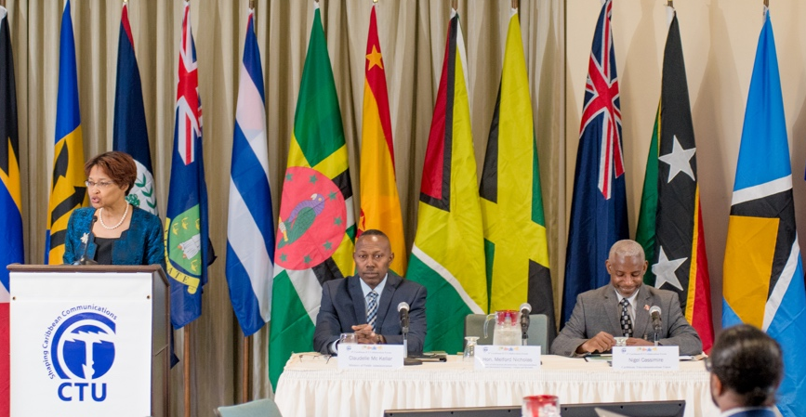
Secretary General Bernadette Lewis welcomes guests at the 4th Caribbean Collaboration ICT Forum. Seated at the head table, l-r: Mr. Claudelle Mc Kellar, Permanent Secretary Ag., Ministry of Public Administration and Mr. Nigel Cassimire, Telecommunications Specialist, CTU.

Port of Spain, Trinidad and Tobago (2nd March 2020) – There is an old adage that says, “it takes a village to raise a child.” Well, as it relates to the Caribbean, it takes many countries to advance a region. This recurring theme was once again the focus of the 4th Caribbean ICT Collaboration Forum of the Caribbean Telecommunications Union (CTU). The 4th convening of this Forum sought to encourage the sharing of information that will allow CARICOM States to avoid duplication of efforts and wasteful use of human and financial resources in advancing their information and communications technology (ICT) agenda both nationally and regionally. The Meeting took place at the Trinidad Hilton and Conference Centre from 11th to 12th February, 2020 and continued the CTU’s 30th Anniversary theme, Digital Transformation – Do it!.
Taking into account the small size and vulnerabilities of individual Caribbean economies, several speakers addressed the dire need for collaboration amongst Caribbean States to ensure the survival of the region.
Addressing the multi-stakeholder audience, Ms. Bernadette Lewis, Secretary General of the CTU stated, “We’ve entered into the 4th Industrial Revolution where the digital, physical and biological spheres are coalescing and the Caribbean is still talking about implementing e-government. We are far behind and one of the reasons for this is that we do not collaborate.”
Secretary General Lewis set the tone for the event as the dire need for collaboration was echoed by others speakers. Hon. Melford Nicholas, Minister of Information, Broadcasting, Telecommunications and Information Technology, Antigua and Barbuda and President of the CTU, explained in his welcome remarks, “ICT has been part of every discussion we’ve had at the CTU. We recognize the need for practical collaboration and commitment to the regional agenda for a CARICOM Single ICT Space. Each government needs to be joined inside the space and this takes collaboration.”
Acknowledging that the region can only move forward on the principle of collaboration, representing Hon. Allyson West, Minister of Public Administration, Trinidad and Tobago, Mr. Claudelle Mc Kellar, Permanent Secretary Ag., continued the dialogue stating that, "The 'Digital Push' requires a collective effort and an integrated Caribbean or a unified Caribbean Single ICT Space. Then and only then we can realise true benefits and deliver borderless services to citizens anytime, anywhere, and on any platform or device across the region."
Orator extraordinaire, Mr. Anthony Watkins, CEO / Principal Consultant Odyssey Consultinc Limited, had the unenviable task of sharing on ‘The Art of Collaboration.’ Mr. Watkins delved into the often overlooked areas of human interaction, highlighting basic skills that aid in the process of collaboration.
“In our interactions, we are making assumptions based on incomplete information. When you understand an individual’s story, only then you will have a deeper appreciation of others and engage with others differently.”
The Forum welcomed participants ranging from Fintech organisations; Regulators, ICT product and service providers; Internet Organisations and Network Operator Groups; Organisations involved in digital transformation; Academia; and Regional and international development agencies.
The Spokesperson for the Caribbean Settlement Network, Ms. Marla Dukheran, Chief Economist at BITT, disclosed startling data on money lost to fees for remittances. Good ICT connectivity can facilitate intraregional payment platforms which would not need not rely on US dollars as the currency of trade. “Without connectivity on mobile devices, none of this would be possible as we would be forever lining up in banks and paying lots of money, as high as 1.7b USD per year in remittances.” She advocated for governments and ICT stakeholders to collaborate so that US$ 1.7B that is lost due to remittances, can remain in the region. She encouraged stakeholders, “You can make this happen.”
On this occasion, the CTU launched the Caribbean Internet Development Foundation. This Foundation would implement national projects to build capacity; develop Internet infrastructure; mobilise communities of interest; train stakeholders to execute specific programmes for improving organisational efficiency, security and productivity; and critically, facilitate digital transformation and the growth of a digital economy.
During the Forum, the Caribbean ICT Collaboration Committee held its 12th Meeting. This Committee provides a platform for service providers, regulators and civil society to discuss issues affecting CARICOM citizenry.
The Committee, comprised of three Working Groups, produced reports on: Connectivity, Convergence and Consumer Issues. At this meeting, Roaming was defined in the context of the CARICOM Single ICT Space and the goal with respect to pricing, as: The abolition or reduction of roaming charges as it relates to CARICOM Citizens in CARICOM States served by service providers operation in one or more CARICOM States. It is anticipated that DIGICEL and Cable & Wireless would continue to have roaming agreements with extra regional carriers whose customers visit CARICOM States.
Sixty persons from across the Caribbean attended the Forum. Ministers and senior officials from Antigua and Barbuda, Bahamas and Montserrat were active participants and contributed to the success of the event.

---END---
The Caribbean Telecommunications Union (CTU) is an inter-governmental organisation dedicated to supporting the development of the Caribbean information and communications technologies (ICT) sector. The CTU also promotes coordination of ICT at the regional level, identifies and removes roadblocks to ICT development, keeps track of industry progress and responds to the needs of the ICT sector, all with the aim of creating a cohesive regional approach to an ICT agenda which embraces the needs of all stakeholders. The CTU is committed to ICT development that reaches the citizens of the region, creating affordable access to ICT and helping citizens to use ICT effectively to transform their lives.
For further information, please contact:
Michelle Garcia
Communications Specialist
Caribbean Telecommunications Union
E-mail: michelle.garcia@ctu.int
Website: http://www.ctu.int/
Tel: 1-868-628-0281, ext. 246
Fax: 1-868-622-6523

